**CSA0410 – OPERATING SYSTEM LAB PROGRAMS**

**DAY 3**

*NAME:S.NAVYA*

*REG.NO:192110511*

**16. Construct a C program to simulate the First in First Out paging technique of memory management**.

#include <stdio.h>

int main()

{

int incomingStream[] = {4, 1, 2, 4, 5};

int pageFaults = 0;

int frames = 3;

int m, n, s, pages;

pages = sizeof(incomingStream)/sizeof(incomingStream[0]);

printf("Incoming \t Frame 1 \t Frame 2 \t Frame 3");

int temp[frames];

for(m = 0; m < frames; m++)

{

temp[m] = -1;

}

for(m = 0; m < pages; m++)

{

s = 0;

for(n = 0; n < frames; n++)

{

if(incomingStream[m] == temp[n])

{

s++;

pageFaults--;

}

}

pageFaults++;

if((pageFaults <= frames) && (s == 0))

{

temp[m] = incomingStream[m];

}

else if(s == 0)

{

temp[(pageFaults - 1) % frames] = incomingStream[m];

}

printf("\n");

printf("%d\t\t\t",incomingStream[m]);

for(n = 0; n < frames; n++)

{

if(temp[n] != -1)

printf(" %d\t\t\t", temp[n]);

else

printf(" - \t\t\t");

}

}

printf("\nTotal Page Faults:\t%d\n", pageFaults);

return 0;

}

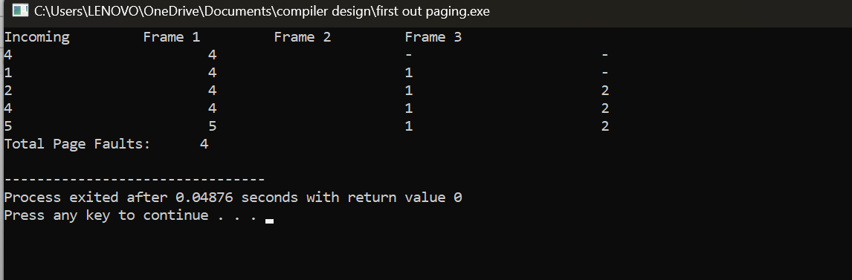

**17. Construct a C program to simulate the Least Recently Used paging technique of memory management.**

#include<stdio.h>

int findLRU(int time[], int n){

int i, minimum = time[0], pos = 0;

for(i = 1; i < n; ++i){

if(time[i] < minimum){

minimum = time[i];

pos = i;

}

}

return pos;

}

int main()

{

int no_of_frames, no_of_pages, frames[10], pages[30], counter = 0, time[10], flag1,

flag2, i, j, pos, faults = 0;

printf("Enter number of frames: ");

scanf("%d", &no_of_frames);

printf("Enter number of pages: ");

scanf("%d", &no_of_pages);

printf("Enter reference string: ");

for(i = 0; i < no_of_pages; ++i){

scanf("%d", &pages[i]);

}

for(i = 0; i < no_of_frames; ++i){

frames[i] = -1;

}

for(i = 0; i < no_of_pages; ++i){

flag1 = flag2 = 0;

for(j = 0; j < no_of_frames; ++j){

if(frames[j] == pages[i]){

counter++;

time[j] = counter;

flag1 = flag2 = 1;

break;

}

}

if(flag1 == 0){

for(j = 0; j < no_of_frames; ++j){

if(frames[j] == -1){

counter++;

faults++;

frames[j] = pages[i];

time[j] = counter;

flag2 = 1;

break;

}

}

}

if(flag2 == 0){

pos = findLRU(time, no_of_frames);

counter++;

faults++;

frames[pos] = pages[i];

time[pos] = counter;

}

printf("\n");

for(j = 0; j < no_of_frames; ++j){

printf("%d\t", frames[j]);

}

}

printf("\n\nTotal Page Faults = %d", faults);

return 0;

}

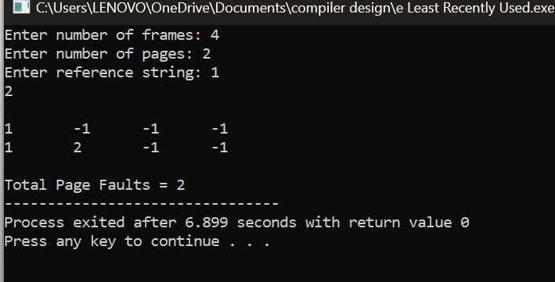

**18. Construct a C program to simulate the optimal paging technique of memory management**

#include<stdio.h>

int main()

{

int no_of_frames, no_of_pages, frames[10], pages[30], temp[10], flag1, flag2, flag3,

i, j, k, pos, max, faults = 0;

printf("Enter number of frames: ");

scanf("%d", &no_of_frames);

printf("Enter number of pages: ");

scanf("%d", &no_of_pages);

printf("Enter page reference string: ");

for(i = 0; i < no_of_pages; ++i){

scanf("%d", &pages[i]);

}

for(i = 0; i < no_of_frames; ++i){

frames[i] = -1;

}

for(i = 0; i < no_of_pages; ++i){

flag1 = flag2 = 0;

for(j = 0; j < no_of_frames; ++j){

if(frames[j] == pages[i]){

flag1 = flag2 = 1;

break;

}

}

if(flag1 == 0){

for(j = 0; j < no_of_frames; ++j){

if(frames[j] == -1){

faults++;

frames[j] = pages[i];

flag2 = 1;

break;

}

}

}

if(flag2 == 0){

flag3 =0;

for(j = 0; j < no_of_frames; ++j){

temp[j] = -1;

for(k = i + 1; k < no_of_pages; ++k){

if(frames[j] == pages[k]){

temp[j] = k;

break;

}

}

}

for(j = 0; j < no_of_frames; ++j){

if(temp[j] == -1){

pos = j;

flag3 = 1;

break;

}

}

if(flag3 ==0){

max = temp[0];

pos = 0;

for(j = 1; j < no_of_frames; ++j){

if(temp[j] > max){

max = temp[j];

pos = j;

}

}

}

frames[pos] = pages[i];

faults++;

}

printf("\n");

for(j = 0; j < no_of_frames; ++j){

printf("%d\t", frames[j]);

}

}

printf("\n\nTotal Page Faults = %d", faults);

return 0;

}

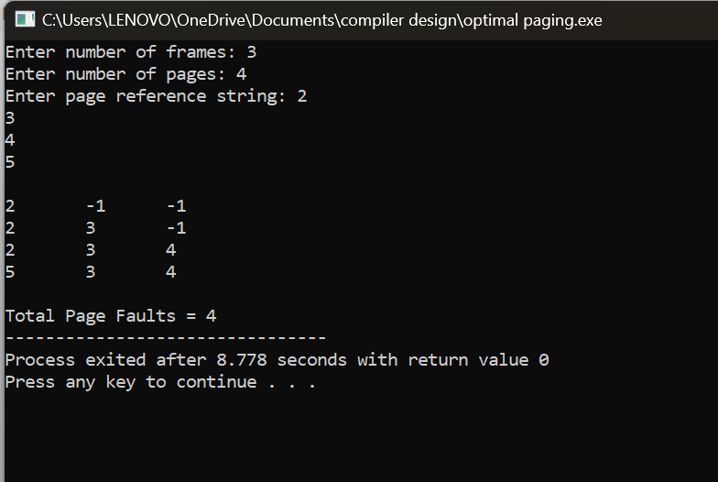

**19. Design a C program to simulate the file allocation strategy.**

#include<stdio.h>

#include<conio.h>

#include<stdlib.h>

int main()

{

int f[50], i, st, len, j, c, k, count = 0;

for(i=0;i<50;i++)

f[i]=0;

printf("Files Allocated are : \n");

x : count=0;

printf("Enter starting block and length of files: ");

scanf("%d%d", &st,&len);

for(k=st;k<(st+len);k++)

if(f[k]==0)

count++;

if(len==count)

{

for(j=st;j<(st+len);j++)

if(f[j]==0)

{

f[j]=1;

printf("%d\t%d\n",j,f[j]);

}

if(j!=(st+len-1))

printf("The file is allocated to disk\n");

}

else

printf("The file is not allocated \n");

printf("Do you want to enter more file(Yes - 1/No - 0)");

scanf("%d", &c);

if(c==1)

goto x;

else

exit(0);

getch();

}

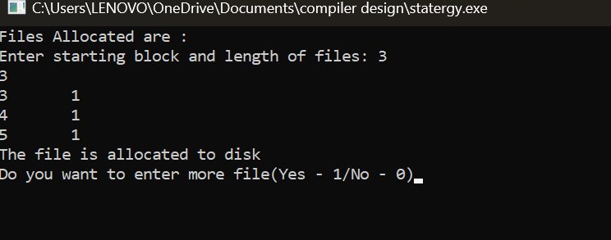

**20. Design a C program to simulate the file allocation strategy**.

#include<stdio.h>

#include<conio.h>

#include<stdlib.h>

int main()

{

int f[50], index[50],i, n, st, len, j, c, k, ind,count=0;

for(i=0;i<50;i++)

f[i]=0;

x:printf("Enter the index block: ");

scanf("%d",&ind);

if(f[ind]!=1)

{

printf("Enter no of blocks needed and no of files for the index %d on the disk : \n", ind);

scanf("%d",&n);

}

else

{

printf("%d index is already allocated \n",ind);

goto x;

}

y: count=0;

for(i=0;i<n;i++)

{

scanf("%d", &index[i]);

if(f[index[i]]==0)

count++;

}

if(count==n)

{

for(j=0;j<n;j++)

f[index[j]]=1;

printf("Allocated\n");

printf("File Indexed\n");

for(k=0;k<n;k++)

printf("%d-------->%d : %d\n",ind,index[k],f[index[k]]);

}

else

{

printf("File in the index is already allocated \n");

printf("Enter another file indexed");

goto y;

}

printf("Do you want to enter more file(Yes - 1/No - 0)");

scanf("%d", &c);

if(c==1)

goto x;

else

exit(0);

getch();

}



**21. Design a C program to simulate the file allocation strategy**.

#include<stdio.h>

#include<conio.h>

#include<stdlib.h>

int main()

{

int f[50], p,i, st, len, j, c, k, a;

for(i=0;i<50;i++)

f[i]=0;

printf("Enter how many blocks already allocated: ");

scanf("%d",&p);

printf("Enter blocks already allocated: ");

for(i=0;i<p;i++)

{

scanf("%d",&a);

f[a]=1;

}

x: printf("Enter index starting block and length: ");

scanf("%d%d", &st,&len);

k=len;

if(f[st]==0)

{

for(j=st;j<(st+k);j++)

{

if(f[j]==0)

{

f[j]=1;

printf("%d-------->%d\n",j,f[j]);

}

else

{

printf("%d Block is already allocated \n",j);

k++;

}

}

}

else

printf("%d starting block is already allocated \n",st);

printf("Do you want to enter more file(Yes - 1/No - 0)");

scanf("%d", &c);

if(c==1)

goto x;

else

exit(0);

getch();

}

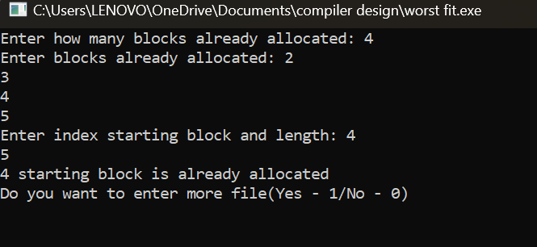

**22. Construct a C program to simulate the First Come First Served disk scheduling algorithm**.

#include <stdio.h>

#include <stdlib.h>

int main() {

int disk_head, num_requests, i;

printf("Enter the current disk head position: ");

scanf("%d", &disk_head);

printf("Enter the number of disk requests: ");

scanf("%d", &num_requests);

int requests[num_requests];

printf("Enter the positions of disk requests:\n");

for (i = 0; i < num_requests; i++) {

scanf("%d", &requests[i]);

}

int total_seek_time = 0;

for (i = 0; i < num_requests; i++) {

total_seek_time += abs(requests[i] - disk_head);

disk_head = requests[i];

}

printf("Total seek time using FCFS: %d\n", total_seek_time);

return 0;

}